**Create and Setup Spring Boot Project in Eclipse IDE**

Procedure:

1. Install Eclipse IDE for Enterprise Java and Web Developer
2. Create a Spring Boot Project in Spring Initializr
3. Import Spring Boot Project in Eclipse IDE
4. Search “maven” and choose Existing Maven Project
5. Choose Next
6. Click on the Browse button and select the extracted zip
7. Click on the Finish button and we are done creating the Spring Boot project

Step 1: Install Eclipse IDE for Enterprise Java and Web Developer

Please refer to this article How to Install Eclipse IDE for Enterprise Java and Web Development and install the Eclipse IDE.

Step 2: Create a Spring Boot Project in Spring Initializr

Go to this link and create a Spring Boot project. Please fill in all the details accordingly and at last click on the GENERATE button below. This will download your Spring Boot project in zip format. Now extract the folder into your local machine. For more details in Spring Initializr refer to this article: Spring Initializr

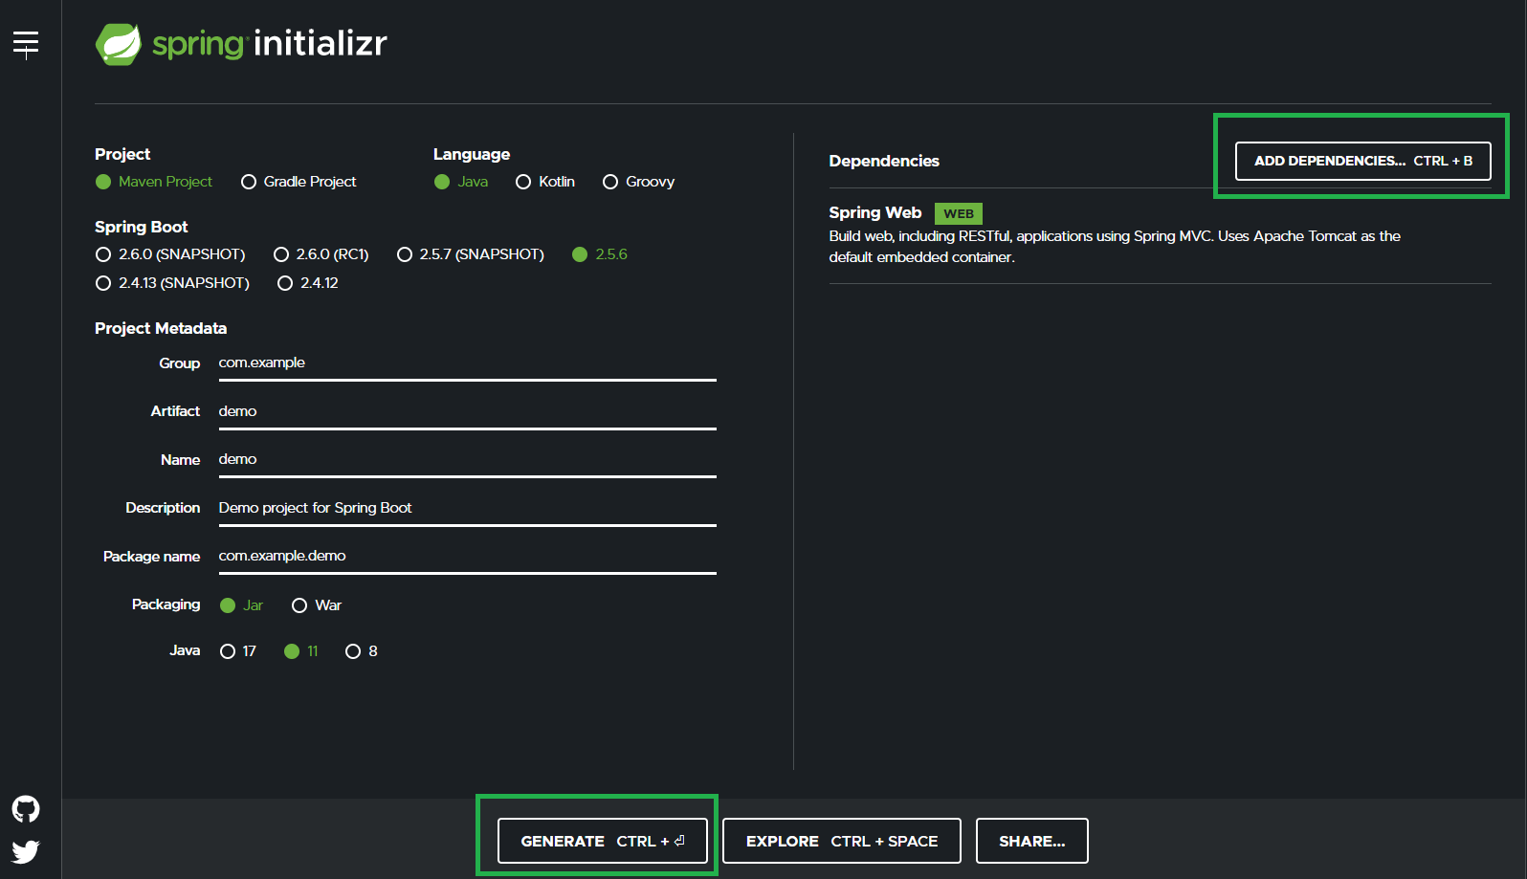

Step 3: Import Spring Boot Project in Eclipse IDE

Go to the Eclipse IDE for Enterprise Java and Web Developer > File > Import as shown in the below image.

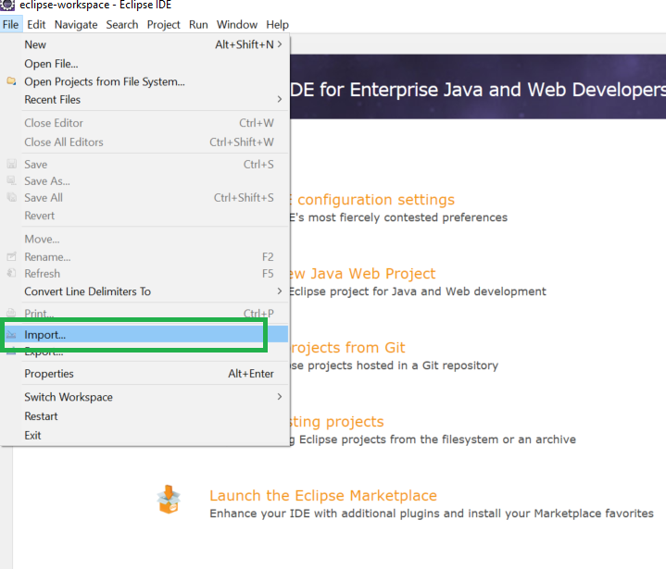

Step 4: Search “maven” and choose Existing Maven Project and click on the Next button as shown in the below image.

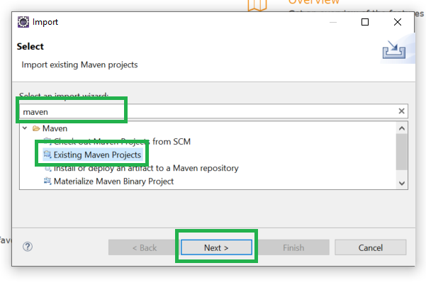

Step 5: Now click on the Browse button and select the extracted zip file that has been generated.

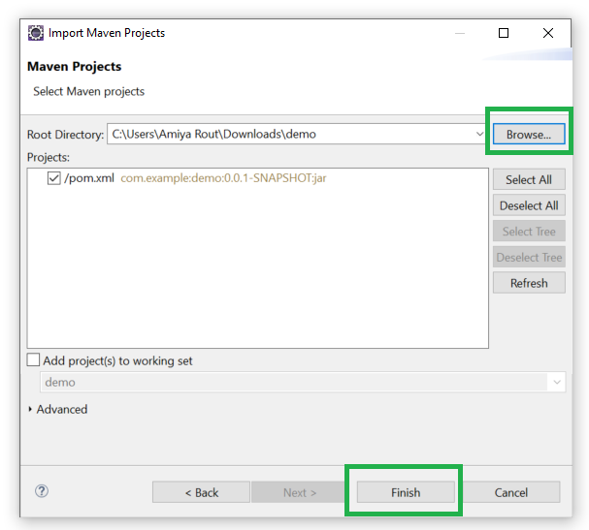

Step 6. And at last click on the Finish button and we are done creating the Spring Boot project

By now, Spring Boot project has been created as depicted in the below media 